The Philosophy of the International Color Science and Art Center

as the Brand Strategy of University

Yasushi Noguchi ¹, Ryuichiro Yoshie ²

¹ Professor, Department of Interactive Media, Tokyo Polytechnic University
2-9-5 Honcho, Nakano, Tokyo, 164-8678, JAPAN
E-mail: noguchi45213@int.t-kougei.ac.jp

² President, Tokyo Polytechnic University
2-9-5 Honcho, Nakano, Tokyo, 164-8678, Japan
E-mail: yoshie@arch.t-kougei.ac.jp

Abstract

A research and branding project on color science and art proposed by Tokyo Polytechnic University (TPU) was adopted as a Private University Research Branding Project sponsored by the Ministry of Education, Culture, Sports, Science and Technology (MEXT). For this project, we established a gallery in the International Research Center for Color Science and Art where children and students can study and enjoy color science by means of educational materials using media arts.
This article introduces the research and branding plan of the project, and the contents of the first exhibition in the gallery.

Keywords; color, engineering and art, media art, photography

I. Introduction

The research and branding project titled “Create Tomorrow, Learn Future, and Connect the World by Color, KOUGEI Color Science and Art” proposed by Tokyo Polytechnic University (TPU) was selected as a Private University Research Branding Project sponsored by the Ministry of Education, Culture, Sports, Science and Technology (MEXT). MEXT supports private universities that conduct research projects revealing the originalities and the characteristics of the universities under the leadership of the presidents.
The TPU originated as the Konishi Professional School of Photography, founded in 1923 to train technicians and researchers in the field of photography, a cutting-edge expressive technology at the time. The school was a pioneer in combining self-expression through photography (art) with photographic techniques (technology). Now the TPU is a unique university in Japan in that it possesses faculties of both engineering and arts. One of the policies of the president of TPU is to enhance further collaboration between technology and art through this project.
We selected “color” as the research theme of the university and built the International Research Center for Color Science and Art. Color is closely related to photography, printing, and optics, which have been the research fields of the TPU from its foundation. The departments of engineering and arts can both conduct researches on color, which will lead to further collaboration between technology and art. Creating genuine harmony between engineering and art is one of the most important policies of the president of TPU. He aims to promote genuine harmony through this research and branding project. We will offer information on the research results by means of media arts such as photography, movies, AR, CG, projection mapping, manga, games, and so forth. This is a unique branding strategy only possible with TPU.
On July 22nd of this year, we opened a gallery in the International Research Center for Color Science and Art.
We discuss the philosophy of the gallery as a branding strategy and introduce the first exhibition of the gallery below.

II. Research and branding strategy of the project

- Promotion of researches on color
Sixteen research themes on color have been selected among 30 research applications from the faculties of engineering and arts. The research themes can be classified as follows.
・Color and psychology
・Color and education
・Color and health, medical, nursing care
・Color and digital archives for cultural assets and artworks
・Color and media arts
・Color and architecture
・Optical devices
As shown above, color is studied in a wide variety of research fields, which are interdisciplinary.
An outline of the research themes can be seen on our special website: https://www.color.t-kougei.ac.jp/

- Branding Strategy
1) Public information on research by means of media arts
We will offer information on the research results on color by means of media arts such as photography, movies, AR, CG, projection mapping, manga, games, and so forth. This is a unique branding strategy only possible with TPU, which has departments of both engineering and arts.

2) Gallery in the International Research Center for Color Science and Art
We opened a gallery where children to high school students can study and enjoy color science and art. We will create educational materials on color using media arts, which will be exhibited in the gallery.

3) Special site on the TPU official website, SNS
We will offer information on the activities of the International Research Center for Color Science and Art on special webpages on the TPU website and SNS (Facebook, YouTube, and so forth)

4) Open seminar and international workshop
We will hold open seminars by members of TPU, other universities, and companies. Research results on color will be presented by TPU members at the end of every fiscal year. We will hold international workshops in which color researchers from overseas universities (e.g. Chinese Culture University, Rochester Institute of Technology, Chulalongkorn University, and University of Eastern Finland) can participate.

5) Participation in the Cultural Power Project of the Agency for Cultural Affairs for Tokyo Olympic and Paralympic Games 2020
The Agency for Cultural Affairs is planning to hold the Cultural Power Project for Tokyo Olympic and Paralympic Games. The purpose is the worldwide dissemination of Japanese cultural attractions. One of the strategies of the Cultural Power Project is to promote the participation of faculty members and students, and innovation and human resources development through harmony between science and art. This strategy is consistent with the spirit of our project, and we will participate in this Cultural Power Project.

III. Gallery Design as a Brand Strategy

From the viewpoint of science and art, it is especially important to research colors and present the results of the research in an easy to understand and experience-based format. Therefore, we will utilize participatory methods such as interactive art technologies.
In addition, we will conduct publicity activities for local residents to encourage them to become familiar with our facility.

- Design of the Gallery
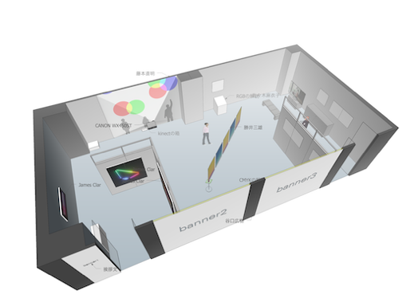
Assumed to be variously utilized, the gallery space has been designed as a modularized facility and environment with high functionality (Fig. 1). In particular, the units of 1.2-meter-wide movable walls can be flexibly arranged so that the space will be used for research presentations and contemporary art exhibitions. Gray is used as the base color of the space with consideration for color of content. As a result, every content in the space can be seen vividly.

Fig. 1 The Design of the Gallery Space

- Gallery Logotype and Sign Design
To increase the brand strength of the gallery, elements representing the nature of color were used in the “col.lab” logotype (Fig. 2). “col” represents color and “lab” represents laboratory so that it is easy to recognize that the research center and gallery is a facility of color research.
Moreover, to obtain familiarity with audiences and to represent the characteristics of a research and education organization, the logotype was designed to be legible, friendly and intellectual.

Fig. 2 The Logotype of the Research Center and Gallery

Since the gallery is on the second floor of the building, a flow line from the outside of the building to the first-floor front space, stairs and gallery was carefully designed (Fig.3). For the stairs, Munsell's color system was adopted to represent the academic characteristics of the galley. It succeeded in combining visitor-friendly information design with the effect of enhancing visitors’ expectations of the gallery.
The logotype and sign design were designed by Masaaki Hiromura, a professor of the visual communication design department of the university.

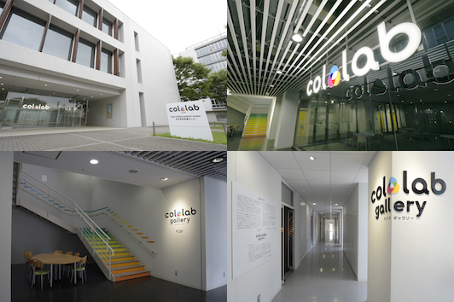

Fig. 3 The Sign System of the Gallery

- Public Relations Activities and Merchandise Development
With the cooperation of a designer, Sadatomo Kawamura, we produced and distributed posters and leaflets for the first exhibition publicity with the design concept of "the fusion of science and art through color" (Fig. 4). Furthermore, in order to stimulate the intellectual curiosity of visitors, a six-page leaflet that explains the purpose of the exhibition, outlines of each participating artist's work and profile, and presents details about the three primary colors of color light and color material was designed. With these printed materials, the activities of the gallery will be advertised and accumulated as a record.
In addition, we developed merchandise (plastic file folder, bookmark) to spread the fun of colors.
Yellow and cyan were printed on the surface of the plastic file folder, and magenta was printed on its reverse side. If the folder is empty, it becomes the three primary colors of cyan, magenta and yellow (CMY), and when a document is in the folder, it becomes the TPU logotype. It can be said that it visualizes the branding of our university as a color research institute. Likewise, the idea of ​​the bookmark is basically the same as the folder. When three pieces (CMY) are overlapped, it becomes the original col.lab logotype. In this case, while having them freely play in the three primary colors of the color materials, we also remind visitors of the logotype at the center, strengthening the brand power.

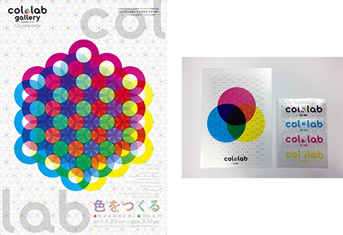

Fig. 4 Leaflet Design (Left), Plastic File Folder, Bookmark (Right)

Press releases were sent to 380 companies including newspaper companies, television stations, publishing houses, and posters and leaflets were posted to 829 locations such as museums, galleries, universities, high schools, elementary schools in Kanagawa, Tokyo, Saitama, Chiba, Ibaraki, Tochigi and Gunma.

- Public Dissemination by Official Website
In March 2017, the official website (https://www.color.t-kougei.ac.jp/) was launched, and 16 research projects, annual plan, project record, introduction of gallery, event information were provided. We will continue to report and update the results of future events.
By integrating the gallery design, logotype, sign design, merchandise development, and publicity on the website, it is possible to strength the brand image of TPU, color research and col.lab gallery.

IV. "Creating Colors" Exhibition

An exhibition titled "Creating Colors: What Color can become Green by Mixing with Red?" has been held from July 22nd, 2017 to March 17th, 2018. As the introduction of the first exhibition, it provides contents to consider how colors are treated in various arts and design expressions (Fig. 5).
How does the color of our surroundings get its color? In our everyday life, we are not conscious of the mechanism and process in creating the colors surrounding us, such as the color of a magazine's photo, the color of clothes, the color of light. However, knowing more deeply how the colors of various things are generated, visitors will recognize the wonder of the color world and the depth of the color and the pleasure.
In this exhibition, we planned to explore the process and mechanism of color creation through art and design works in various fields such as interactive art, light art, printing, traditional crafts and so forth.

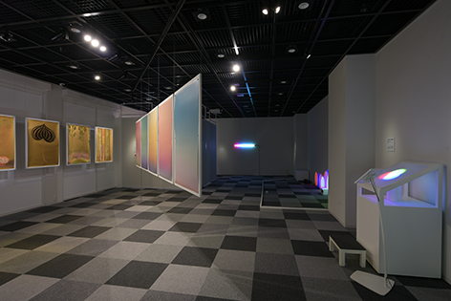

Fig. 5 “Creating Colors” Exhibition

- Exhibited Works
- Light Art (James Clar)
The media artist James Clar is exploring the influence of media and technology on the recognition of culture and identity. One of Clar's works is a 3D display cube that contains 1000 LEDs soldered in a patented wiring matrix configuration. He is a new generation of light-focused artists from Dan Flavin to Olafur Eliasson. In this exhibition, his works focusing specifically on color have been presented (Fig. 6).

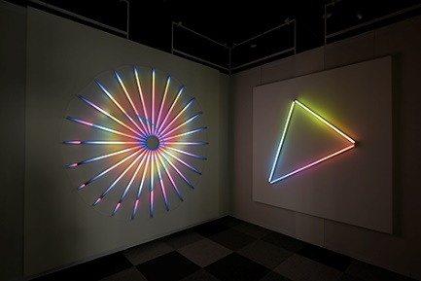

Fig. 6 Light Art Projects by James Clar

- Interactive Art (Naoaki Fujimoto)
An interactive art work in which participants can play with balls of the three primary colors of red, green and blue light projected on the wall with their shadows. As balls of different colors overlap, various colors are produced by the synthesis of light colors (Fig. 7). This art work occupies an important position as an experiential educational work.

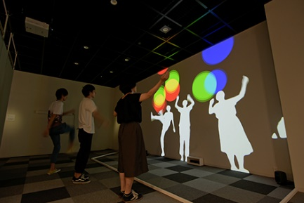
Fig. 7 Visitors Playing with Interactive Art by Naoaki Fujimoto

- Color in Printing (Mitsuo Katsui)
The work implies "Limits to Growth" with an egg which is a metaphor of the Earth (Fig. 8). The data used to depict the shell of eggs are 60 million pixels, realizing high resolution image quality with the performance of sensors and lenses. Furthermore, it uses advanced printing technology of two more special inks to create a smooth gradation exiting in the light space.

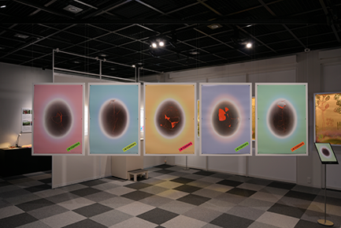

Fig. 8 Limits to Growth, Five Set of Posters by Katsui Mitsuo

- Color in Printing (Hiroki Taniguchi)
The author has long been committed to gold, dreaming of using golden paper or gilded ink to create works. In 2006, in collaboration with the printing director of the "Graphic Trial" sponsored by Toppan Printing Co., Ltd. [1], he pursued golden expression in offset printing (Fig. 9).

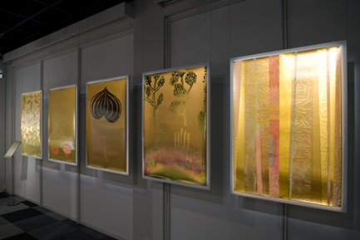

Fig. 9 Five Set of Posters by Hiroki Taniguchi

- Traditional Colors (Maiko Sasaki)
A document that carefully follows the generation and purification processes of Beni (red) from ancient times in Japan.
It beautifully depicts the process of purifying a little red pigment contained in a yellow safflower with a filament of hemp. This experimental film work describes the secret of the special beauty of red through the process of refining transparent red (Fig. 10).

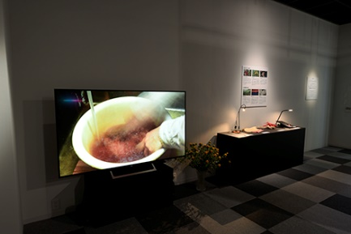

Fig. 10 Beni by Maiko Sasaki

- Mechanism of Color Systems (students of Software Design Course, Department of Interactive Media)
Through this work, students participate in exhibition projects. Making use of young sensibilities and intelligence, we aim to make the gallery a place where students can grow.
Using the “three primary colors of material” device, visitors can experience a full-color printing scheme by overlapping cyan, magenta, yellow and black (CMYK) plates [2, 3]. On the other hand, using the “three primary colors of light” device, users can adjust the brightness of red, green and blue lights on an iPad and the device, and by mixing these colors, numerous colors are produced (Fig. 11).
Both devices were designed for kids, so that they could gain new experiences and surprises by manipulating the devices. As a result, these works met with a favorable evaluation by visitors.
Students presented various ideas on how to design user experiences, and voluntarily managed the schedule to finish the work.

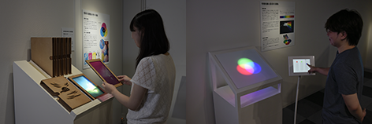
Fig. 11 Devices Explaining the Mechanism of CMYK (Left) and RGB (Right)

- Hands-on Workshop for Creating Colors
As a related project of the exhibition, two hands-on workshops titled Let’s Make a Color Mixer and Let’s Enjoy Polarized Color were led by the Department of Media and Image Technology, Faculty of Engineering, in which participants are encouraged to move hands to create colors (Fig. 12). In this workshop, participants can learn scientific principles, as well as having an interest in the mysteries of creating colors by themselves.

- Let's Make a Color Mixer
The color mixer is a DIY tool kit for leaning the principles of the three primary colors of light.
They build a simple circuit and light up the three LEDs of red, green and blue, mixing the three lights by turning the knob of the resistor to produce various colors.

- Let’s Enjoy Polarized Color
This workshop utilizes polarization, which is a physical phenomenon of light (It will be held on November 11th, 2017).
When a cellophane is interposed between two polarizing plates, light refracts in complicated directions and changes to various beautiful colors. It is effective as a hands-on learning for elementary school students in particular because expressions like stained glass color can be obtained easily.

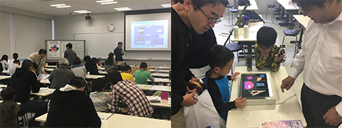

Fig. 12 Workshop View

V. Results

As result of the press releases, information of the gallery and exhibition was posted in Mainichi Newspapers, Asahi Newspapers, regional information magazines, websites and so forth, which attracted visitors. On the first day of July 22nd, 2017, 283 visitors enjoyed the gallery. As of October 18th, 2017, more than 1,000 guests had visited.
While visitor numbers decreased in October, we held a hands-on workshop in the same facility of the gallery on October 15th, and 42 participants joined the workshop. This workshop contributed to the number of visitors of the gallery. As a result, 94% of participants answered it was a "fun" workshop in the questionnaires on the contents of the workshop.
In terms of the difficulty of the workshops, 14% answered it was “easy,” 64% answered it was “normal.” Hence, the content and difficulty of the workshop were considered appropriate.

VI. Conclusion

Information on the opening of the gallery was posted in various media and the number of visitors has increased. Therefore, the promotion activities are considered successful. It is necessary to maintain the number of visitors by continually conducting public relations activities. Working on children's hands-on workshops and international symposiums, we will promote brand recognition, and organize groups from elementary and junior high schools in the local area.
Sixteen collaborative researches started in 2017 and concrete results will be reported in Fiscal 2018. As an index for managing progress, it is obligatory for the project researchers to submit an implementation status report to an administration committee every three months, and progress is generally smooth. In Fiscal 2018, it is expected that the achievements of each project's research results will be accumulated in the form of papers, academic presentations and exhibitions.
However, at the External Evaluation Committee, there were questions about the number of cases of collaboration between the engineering and the art department faculty among the 16 projects, and there are currently only two cases. Therefore, the fusion of the faculties of engineering and of art should be increased. We will enhance the number of collaborative research projects between the faculties of engineering and art more proactively.
Moreover, as mentioned above, the official website has been released and updated as planned, but we have not yet started public relations activities on social networks (SNS). It is necessary to strengthen the brand recognition through SNS and promote the establishment of Tokyo Polytechnic University brand in color research.

Acknowledgement

This research was supported by the Private University Research Branding Project sponsored by the Ministry of Education, Culture, Sports, Science and Technology (MEXT).

References

- Toppan Printing Co., Ltd., Graphic Trial, Graphic-sha Publishing, 2015.
- K. Jo, The Mechanism of Color, SHINSEI Publishing, 2009.
- Newton Press, The Science of Light and Color, Newton Press, 2015.

